**Flowchart of the Application**

Prompts that the file does not exist

Delete file it is if exist

Prompt that file does not exists

Return File name if it is exists

**Choice4Search Files**

List Files in ascending order

**Choice5 Sort Files**

**Choice6Return**

Prompts file exist

Add Files if does not exists

Exist the application

List Files Present

**Choice7Exit**

**Choice3Delete Files**

**Choice2**

**Add Files**

**Choice1list existing files**

Main Context (7 Choices)

**Working of the Application**

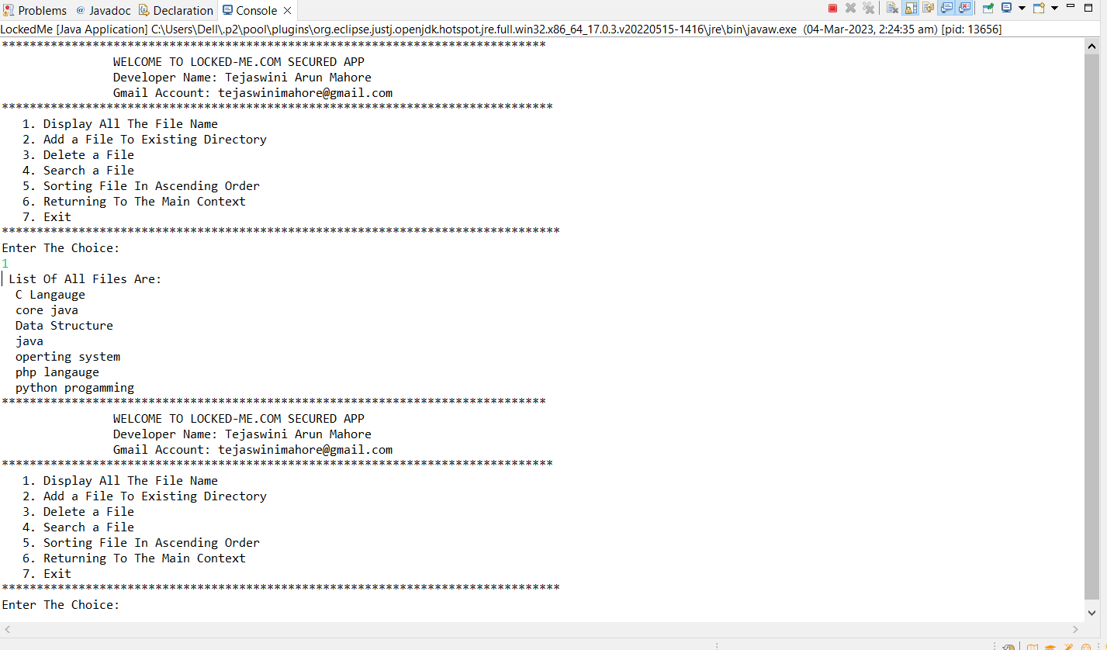

Output:- Retriving All Files Name

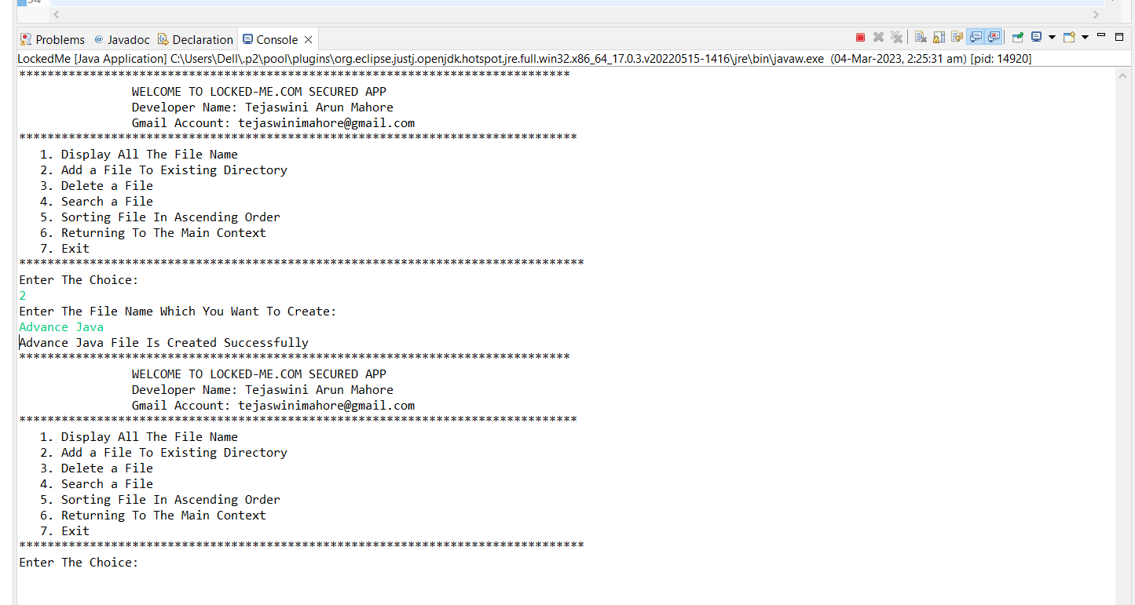

Output:- Adding Files To the Existing Directory

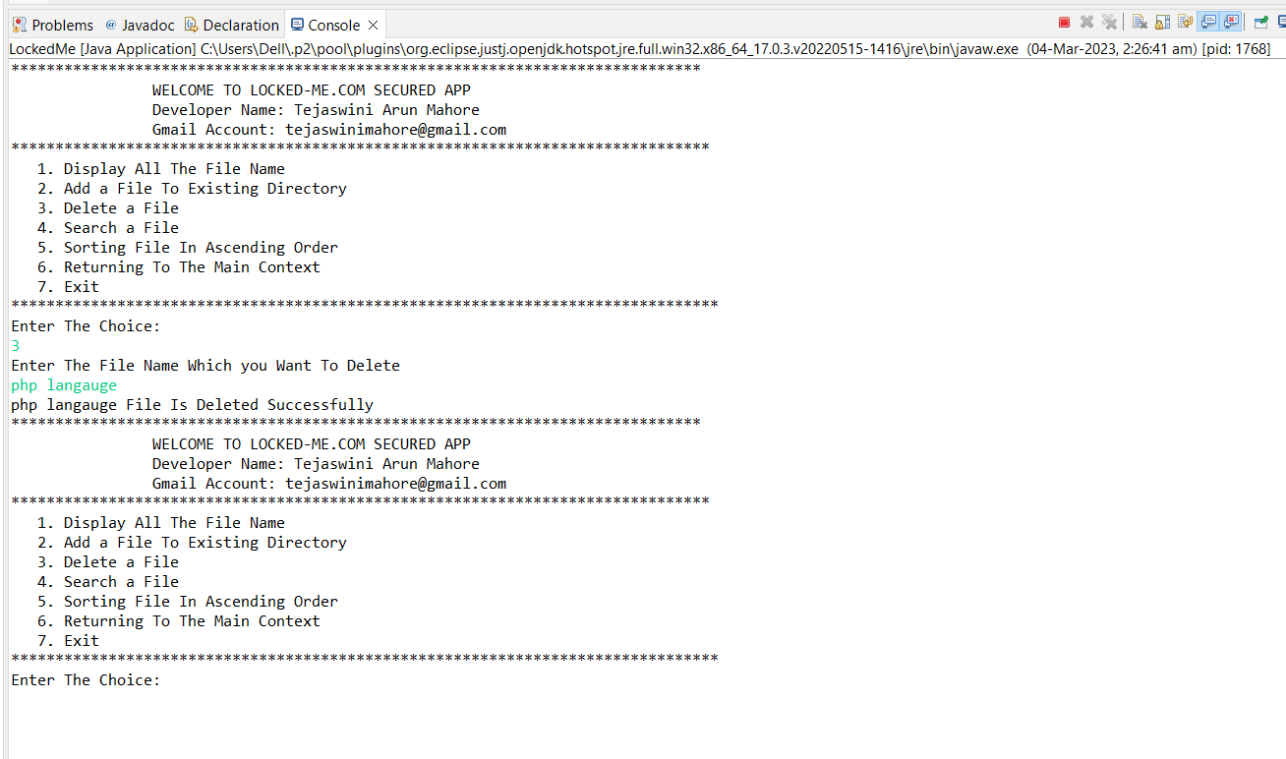

Output:- Deleting Files From a Directory

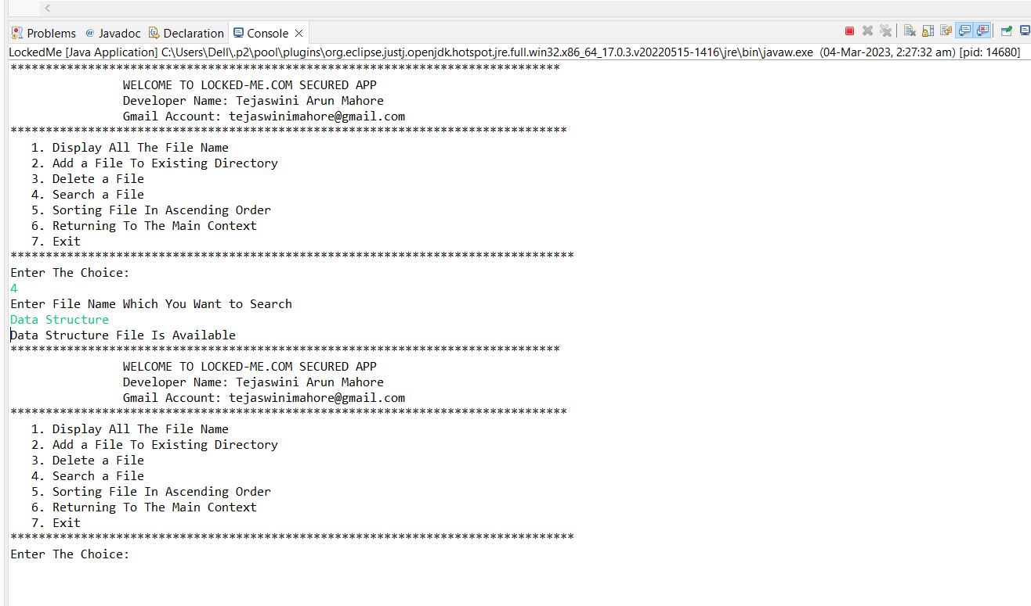

Output:- Searching Files From a existing Directory

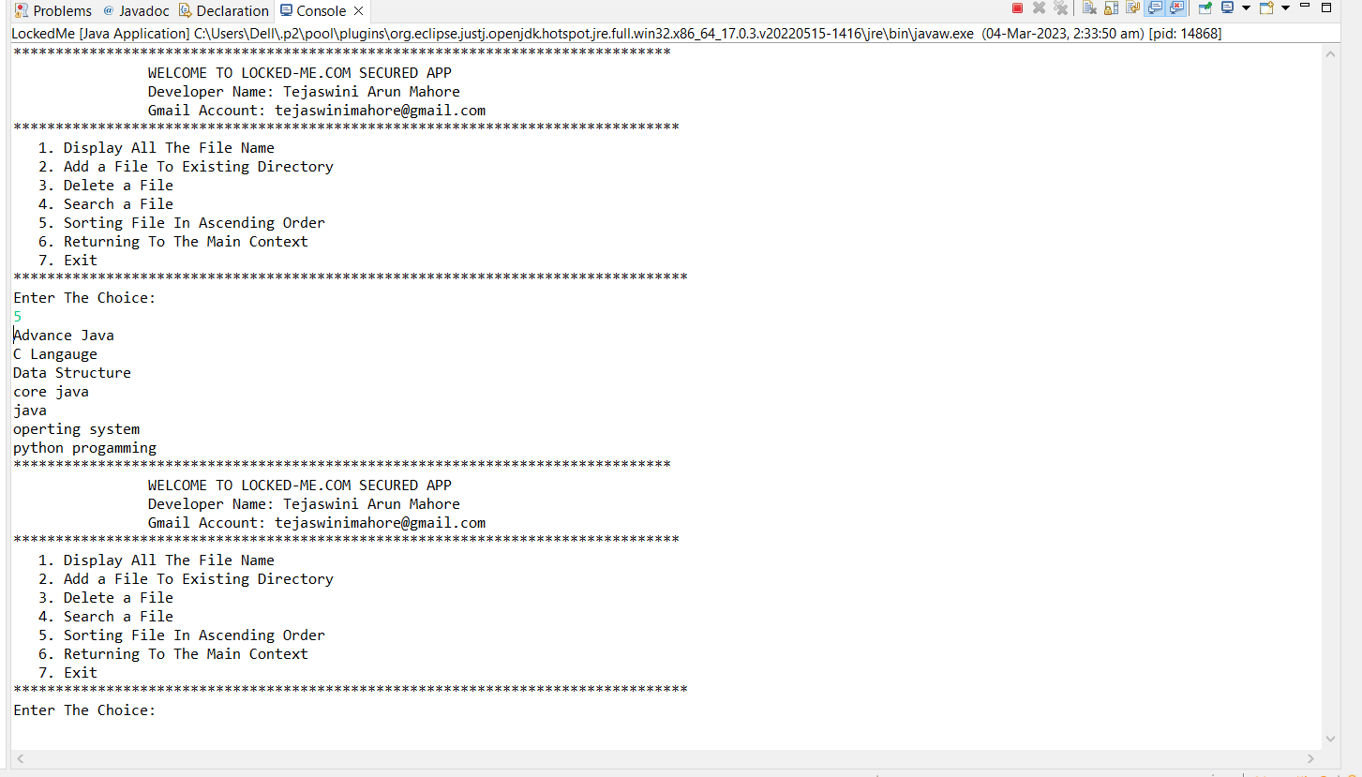

Output:-Sorting a Files in Ascending Order

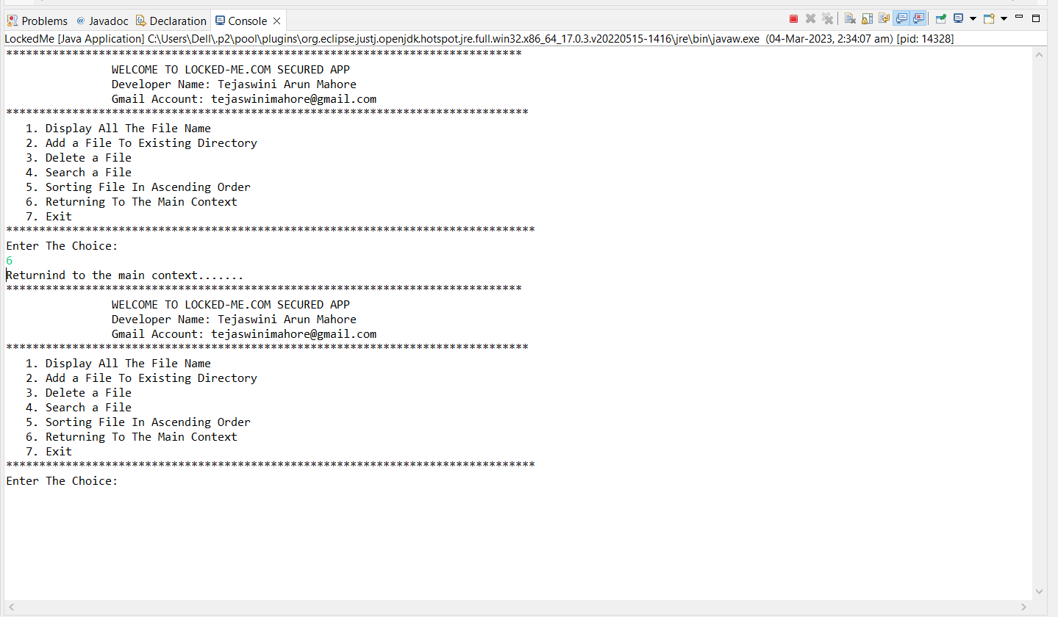

Output:-Returning back from Current context to the Main Context

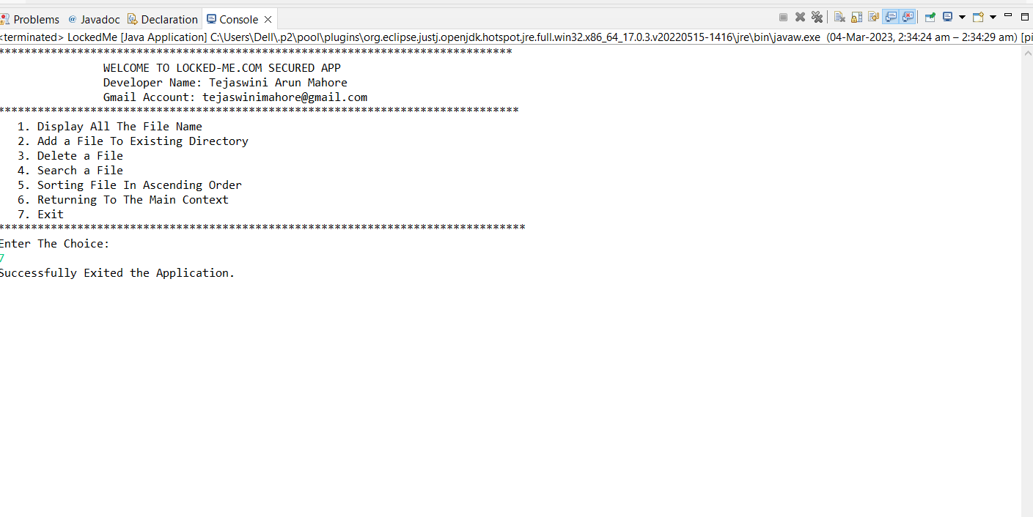

Output:- Exit The Application